**Soil Analyzer**  
*Analyse the soil fertility with the essential nutrients present in the soil*

Prakash Y Jagadeesh S Dr. P. Rama

[py3196@srmist.edu.in](mailto:py3196@srmist.edu.in) [js9441@srmist.edu.in](mailto:js9441@srmist.edu.in) ramap@srmist.edu.in

**Abstract:**

India, the world's second-most populous nation, is deeply rooted in agriculture, with 60% of its population engaged in farming. However, traditional farming practices have led to significant challenges, including reduced productivity and soil degradation. To address these longstanding issues, we are embarking on a transformative mission to harness the potential of machine learning to revolutionize Indian farming.

Machine learning, often perceived as complex, excels at processing specific data, uncovering insights for informed decisions. In the agricultural context, it's a potent tool for reshaping traditional practices. Our primary focus is on modernizing soil analysis, which has traditionally been labor-intensive and time-consuming, leading to delayed decision-making—a luxury that farmers can ill afford. By leveraging machine learning, we aim to provide swift and precise solutions, offering real-time insights into soil fertility for farmers. This project seamlessly aligns with the broader objective of bolstering food security and promoting sustainable agricultural practices. The impact of this technological transformation transcends the farm, nurturing both agriculture and the environment in a mutually beneficial relationship where both thrive.

As we delve into the "Soil Analyzer" project, our vision is clear: to empower India's farming community with knowledge and arm them with the tools for informed decisions. We aim to guide agriculture toward a prosperous, sustainable, and environmentally responsible future. With technology as the catalyst, Indian farming is poised for a revolution that will benefit not only the farmers but also the entire nation, ensuring a brighter future for India's agricultural landscape. This mission is driven by the urgent need to modernize agriculture in India and to provide solutions that empower farmers and contribute to the nation's food security and environmental sustainability.

Keywords: Agricultural Decision Support; Predictive Modeling; User-Friendly Interface; Fertilizer Optimization; Soil Parameters; SFI (Soil Fertility Index); Random Forest; Machine Learning

**Introduction:**

The "Soil Analyzer" project represents the forefront of a transformative wave sweeping through agriculture. At its core, the project sets out to harness the extraordinary capabilities of machine learning to predict soil fertility, introducing an innovative solution that promises to amplify the efficiency and cost-effectiveness of farming practices. This endeavor hinges on the analysis of a comprehensive and diverse dataset, which includes a spectrum of critical soil parameters, ranging from pH levels to micronutrient concentrations and the intricate nuances of soil texture. Through the meticulous curation and processing of this dataset, we've engineered a revolutionary scientific formula for calculating the Soil Fertility Index (SFI), providing farmers with a definitive, action-oriented measure of soil quality, graded on a scale from 1 to 10.

Central to the success of this pioneering project is the dataset itself—carefully curated and refined, it serves as the bedrock of our innovative approach. The dataset includes an array of indispensable features intricately linked to soil fertility, from fundamental parameters like pH and electrical conductivity (EC) to more complex variables such as organic carbon (OC) and a spectrum of essential micronutrients—nitrogen (N), phosphorus (P), potassium (K), sulfur (S), calcium (Ca), magnesium (Mg), zinc (Zn), copper (Cu), iron (Fe), manganese (Mn), boron (B), molybdenum (Mo)— to soil texture (Tex). The integration of the groundbreaking SFI score into the dataset creates a clear and tangible target variable for model development, enabling precise predictions of soil fertility based on the provided input parameters. The primary goal of this project is to empower farmers with a potent tool that enables the optimization of their agricultural practices. With the ability to predict the SFI, farmers can make informed decisions about fertilizer application, saving invaluable time and resources. A lower SFI value signifies land areas with suboptimal fertility, while a higher SFI indicates the potential for bountiful cultivation. Equipped with this knowledge, farmers can accurately gauge the fertilizer required to enhance their soil's fertility. For instance, a farmer with an SFI of 7.5 can aspire to raise their land's fertility to the maximum score of 10, comprehending the amount of fertilizer needed to elevate the SFI by 2.5 points.

To enhance accessibility and usability, our project will incorporate the development of a user-friendly interface. Farmers will have the capability to input pH values and micronutrient content directly into the interface, receiving instant SFI values. This feature not only simplifies the process but also empowers farmers to make data-driven decisions with ease.

Beyond its immediate applications, this pioneering project possesses the potential to guide farmers toward not only cost efficiency but also long-term sustainability. Moreover, it serves as a driving force for continuous research and experimentation, advancing the optimization of fertilizer usage for soil enhancement. The "Soil Analyzer" project signifies a momentous stride toward a more prosperous, environmentally conscious, and productive future for agriculture, redefining the boundaries of what's achievable in farming and food security.

**Literature review:**

The available research, as evidenced by numerous research papers [2-16], illustrates a diverse landscape of approaches for assessing soil fertility and managing crops. These systems each have their unique merits and demerits, reflecting the evolving nature of agricultural technology.

One of the primary merits of these solutions is their ability to provide cost-effective and reliable options for soil analysis. Many studies advocate the use of IoT-based technologies, allowing real-time monitoring of soil conditions. This innovation empowers farmers with continuous insights into their soil's health, facilitating immediate decision-making, particularly concerning the application of fertilizers and crop management [9, 12-16]. Furthermore, colorimetry and microcontroller-based analyzers are praised for their speed and portability, making them ideal tools for on-site soil nutrient detection, offering swift and actionable results for farmers [13, 15].

However, these systems are not without their limitations. Traditional soil testing methods, which continue to be prevalent, often involve time-consuming and labor-intensive procedures, which can hinder the timely response needed in dynamic agricultural settings [2, 10]. Furthermore, relying on a limited set of parameters in these methods may lead to recommendations that do not fully capture the complex dynamics of soil fertility [10]. This can result in suboptimal agricultural practices. Traditional methods may also suffer from reduced accuracy due to factors such as soil heterogeneity, making localized recommendations less dependable [10]. IoT-based solutions, while providing real-time data, may still fall short in offering comprehensive predictive insights into soil health, potentially limiting their capacity for proactive decision-making [16].

In contrast to these approaches, the Soil Analyzer presents a promising alternative by leveraging advanced algorithms, including deep learning, convolutional neural networks, and machine learning techniques [2]. This approach offers a more holistic view of soil fertility, encompassing a broader range of parameters and historical data to deliver precise recommendations [2]. By merging technology with agricultural knowledge, this innovative system has the potential to revolutionize the farming landscape, enhancing the efficiency and productivity of crop management. With its focus on predictive modeling and the integration of diverse soil attributes, it stands out as a promising solution in the field of soil fertility analysis and crop prediction [2]. This depth and breadth of analysis, driven by cutting-edge technology, could be a game-changer in helping farmers make informed decisions, thereby elevating the agricultural sector to new heights.

The available solutions indeed offer a multitude of valuable advantages that contribute to their relevance in soil analysis and agricultural management. One of their key merits lies in their preference for well-established and cost-effective methods for assessing soil properties, ensuring that farmers can access reliable data without a substantial financial burden, a critical factor in resource-constrained agricultural settings [12-16]. Moreover, recent research has underlined the prowess of IoT-based solutions, enabling continuous and real-time monitoring of soil conditions, which equips farmers with timely insights into the ever-changing state of their soil, supporting informed decisions regarding fertilizer application, crop management, and other vital farming activities [9, 12-16]. Furthermore, the availability of colorimetry and microcontroller-based analyzers is indeed a boon to the agricultural community, offering swift and portable tools that facilitate on-the-spot soil nutrient detection, providing immediate feedback to farmers for quick decision-making, which is often pivotal for effective agricultural practices [13, 15].

Nonetheless, these approaches are accompanied by a set of significant limitations that necessitate consideration [2, 10, 16]. Their reliance on conventional soil testing methods, for instance, is known to be labor-intensive and time-consuming, which can be particularly challenging in the context of fast-paced and dynamic agricultural operations [2, 10]. The traditional approach, often focusing on a limited set of parameters, may inadvertently lead to suboptimal recommendations for crop management, particularly when dealing with the intricacies of soil fertility, where a comprehensive view is crucial for well-informed decisions [10]. Furthermore, the accuracy of these methods can be significantly impacted by variables such as soil heterogeneity, rendering localized recommendations less reliable, thereby posing challenges in diverse agricultural settings [10]. Another drawback often observed in IoT-based solutions is their potential inability to provide in-depth predictive insights into soil health, somewhat limiting their capacity for proactive decision-making [16]. In contrast, the innovative Soil Analyzer you propose capitalizes on advanced algorithms, promising a more holistic view of soil fertility, considering a broader range of parameters and incorporating historical data, addressing some of the limitations present in the current approaches [2].

**Proposed Methodology:**

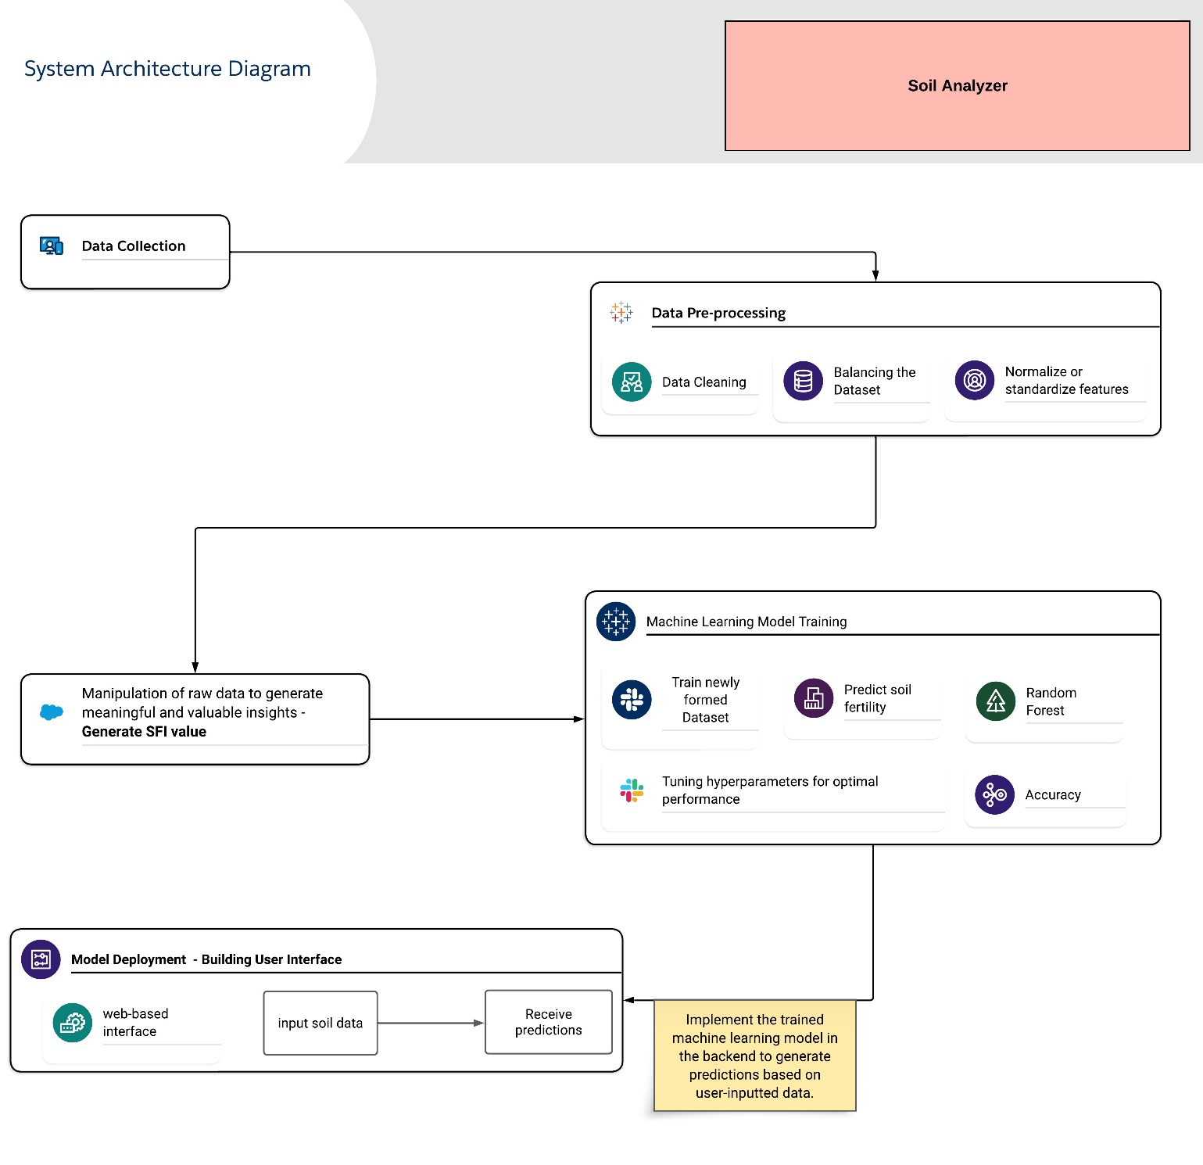

The methodologies employed in this innovative venture were designed to harness the potential of machine learning and data analysis, offering a dynamic solution to the persistent challenges faced by Indian farmers. Soil fertility, a cornerstone of successful agriculture, became the focal point of our study.

We outline the systematic methodology of the 'Soil Analyzer' project, covering data collection, preparation, and the creation of a user-friendly interface. These procedures underpin the development of the innovative system. Below are the step-by-step methods performed in developing this project.

1. **Data Collection:**

Our data collection phase involves sourcing a comprehensive dataset prepared by the eminent G. B. Pant University of Agriculture and Technology. This dataset serves as a goldmine of information, encapsulating a plethora of soil attributes that are crucial for assessing soil fertility and overall quality. These attributes encompass vital parameters such as nutrient levels, including nitrogen (N), phosphorus (P), potassium (K), calcium (Ca), and sulfur (S), as well as fundamental characteristics like pH, organic carbon (OC), electrical conductivity (EC), and a host of other pertinent soil properties. Each data point within this dataset represents a piece of the puzzle that, when analyzed systematically, offers invaluable insights into the health and quality of the soil under examination.

1. **Data Pre-processing:**

The journey towards meaningful soil analysis starts with data pre-processing, where we strive to ensure that our dataset is as pristine and reliable as possible. The first task is to address any gaps or missing values within the dataset. In our commitment to data integrity, these null values are filled judiciously, typically by substituting them with either the mean or median value of the respective column. This meticulous process ensures that no gaps in the dataset compromise its completeness and quality. Furthermore, data pre-processing involves handling potential outliers or anomalies within the data. These outliers, if left unaddressed, could distort the results and predictions generated by our machine-learning model. Therefore, they are meticulously identified and dealt with using appropriate techniques to maintain the dataset's integrity.

Another critical aspect of data pre-processing is the standardization of features. The use of StandardScaler from the scikit-learn library helps us standardize the values within each feature. This standardization ensures that the various parameters in the dataset are on the same scale, preventing one feature from dominating the model's learning process due to a large numerical range.

Data collection and preparation serve as the bedrock of our Soil Analyzer project. The dataset, meticulously sourced from a reputable institution, is carefully cleaned and enriched to ensure its reliability and readiness for subsequent stages. This phase ensures that our project has a strong and reliable foundation, setting the stage for meaningful and precise soil analysis. The prepared dataset now serves as the canvas upon which we paint a comprehensive picture of soil fertility and quality.

1. **Generating SFI Score:**

The Soil Fertility Index (SFI) is a fundamental component of the Soil Analyzer project, serving as a comprehensive measure of soil fertility. It is a result of intricate calculations that provide insights into the health and vitality of the soil. The generation of SFI involves assessing various key attributes in the dataset, which together define soil health. This assessment encompasses factors such as nutrient levels, pH, electrical conductivity (EC), organic carbon (OC), and soil texture. Each of these aspects contributes to the SFI, reflecting its role in determining soil fertility.

The SFI is not just a numerical value; it's a compass guiding agricultural decisions. The SFI, derived through these interconnected scores, represents a holistic and precise evaluation of soil fertility. It brings together the multi-dimensional aspects of soil health into a single numerical rating, simplifying the understanding of soil quality for farmers and agricultural experts. It offers users actionable insights into areas that require improvement, be it nutrient enrichment, pH adjustment, salinity control, organic matter addition, or soil texture modification. By integrating these parameters into the SFI, the project simplifies soil quality understanding for farmers and agricultural experts, facilitating informed decisions to enhance agricultural productivity and sustainability. The SFI is pivotal in the journey towards data-driven, environmentally responsible farming practices.

1. **Data Preparation and Splitting:**

The first step is to gather a comprehensive dataset, including soil samples with known SFI values and relevant parameters such as pH, texture score, OC score, EC score, and nutrient score.

This dataset is then divided into training and testing sets. The training set is utilized to train the machine learning model, while the testing set is reserved for evaluating model performance.

1. **Machine Learning Model Training:**

In this step, a machine learning model is selected based on its suitability for the SFI prediction task. For the purpose of SFI prediction, the Random Forest model was chosen due to its effectiveness in handling complex datasets and providing feature importance scores.

The target variable, SFI, is defined, along with the feature variables, which include pH, texture score, OC score, EC score, and nutrient score.

The machine learning model is trained on the training data to predict SFI based on these feature variables.

1. **Feature Importance Analysis:**

After the model is trained, feature importance scores are generated. The feature importance scores are typically represented as numerical values, ranging from 0 to 1. A score of 0 suggests that a feature has no impact on the model's predictions, while a score of 1 implies that a feature is of utmost importance.

1. **Feature Selection and Normalization:**

After generating feature importance scores, we conduct feature selection to understand the relative importance of pH, texture, OC, EC, and nutrient scores in predicting SFI. Additionally, we normalize these scores, rescaling them to a consistent range, typically between 0 and 1, ensuring each feature contributes proportionally to the overall SFI calculation. This enhances the accuracy and effectiveness of our Soil Analyzer project.

1. **Weight Assignment:**

Based on the feature importance scores, weights are assigned to each parameter in the SFI formula. Parameters with higher feature importance receive higher weights, reflecting their greater influence on soil fertility.

The SFI formula is defined as follows:

*SFI = (Weight_PH * pH + Weight_Texture * Texture_Score + Weight_OC * OC_Score + Weight_EC * EC_Score + Weight_Nutrient * Nutrient_Score) / (Weight_PH + Weight_Texture + Weight_OC + Weight_EC + Weight_Nutrient)*

**pH:** Represents the pH value of the soil.

**Texture_Score:** A score reflecting the soil's texture.

**OC_Score:** A score representing the organic carbon content.

**EC_Score:** A score reflecting the electrical conductivity of the soil.

**Nutrient_Score:** A score representing the overall nutrient content.

The assignment of scores for each feature is tailored to the specific requirements of soil attributes. For instance, consider the element nitrogen (N). If the nitrogen content in the soil falls within the range of 0 to 280 units, it is assigned a score of 1, signifying a lower nutrient level. Soil samples with nitrogen levels ranging from 281 to 560 units are assigned a score of 2, indicating a moderate nutrient content. On the other hand, soil samples with nitrogen levels exceeding 560 units receive a score of 3, denoting a higher nutrient content. Similar score assignment criteria are applied to other nutrient elements based on their respective optimal ranges for plant growth and soil health. This approach ensures that the Nutrient_Score reflects the specific nutrient status of the soil, contributing to a comprehensive evaluation of its fertility. A similar custom score assignment is implemented for other attributes such as pH, soil texture, organic carbon content, and electrical conductivity, aligning the scores with the specific soil health requirements.

This formula allows for the calculation of the SFI value for a specific soil sample based on the assigned weights and the feature values of the soil. By implementing this formula, users can obtain a precise numerical assessment of soil fertility.

**The formula for normalization:**

*normalized_scores = (scores - min(scores)) / (max(scores) - min(scores))*

This formula rescales the feature importance scores to a consistent range between 0 and 1.

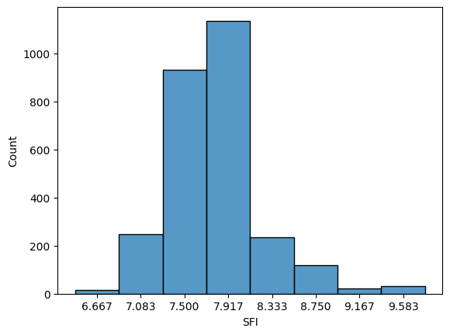

The distribution's breadth underscores the inherent variability in soil fertility, emphasizing the need for tailored agricultural strategies. Farmers can harness this wealth of data to set fertility targets, gauging the extent of improvement required for their specific land areas. Informed decisions are now at their fingertips, enabling precision in fertilization and soil management practices. Additionally, the distribution may unveil outliers or anomalies, flagging potential data quality issues or unique soil conditions that warrant closer scrutiny.

1. **Machine Learning Model Training and Evaluation:**

Traditional methods of soil fertility assessment have often been plagued by inefficiencies, inaccuracies, and the lack of real-time insights. Soil tests conducted in laboratories are typically time-consuming and can lead to significant delays in decision-making for farmers. These tests may not always provide immediate data, limiting their utility in managing crop cultivation and nutrient application. In stark contrast, machine learning models excel at processing vast datasets swiftly and generating real-time predictions. By leveraging the capabilities of machine learning, the Soil Analyzer project seeks to overcome these limitations, offering a modern and efficient solution to soil fertility assessment.

the Soil Analyzer project embarked on a comprehensive evaluation of multiple regression algorithms to determine the most suitable approach for predicting soil fertility with precision. The project's unwavering commitment to accuracy prompted a systematic exploration of various algorithms, including Support Vector Machines (SVM), Decision Trees, and Random Forests.

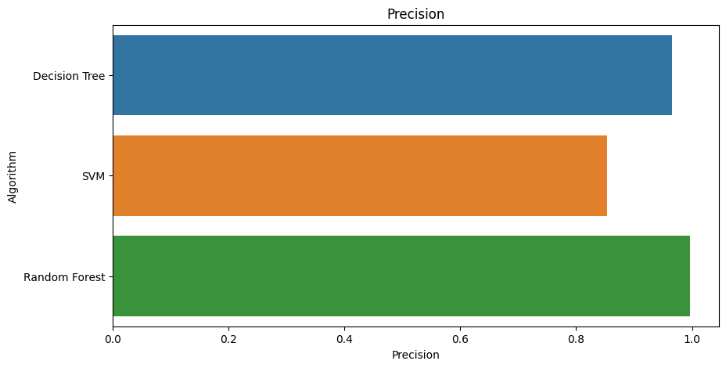

Among the algorithms evaluated, Random Forest stood out due to its exceptional accuracy and robustness in regression tasks. Random Forest is an ensemble learning method that combines the predictions of multiple decision trees. This ensemble approach not only enhances predictive accuracy but also mitigates the risk of overfitting, ensuring that the model generalizes well to unseen data.

The selection of Random Forest as the final algorithm for the project was based on its outstanding performance, particularly its ability to minimize errors. It exhibited a mean absolute error of only 0.03 degrees and an impressive accuracy score of 99.66%. The model's capability to generalize its understanding to new soil samples, its resistance to outliers, and the invaluable insights it provides into feature importance played pivotal roles in this decision. These results were a testament to the model's precision and reliability.

1. **Model Deployment and User Interface:**

The Soil Analyzer project goes beyond merely predicting soil fertility; it presents a comprehensive solution that prioritizes accessibility, user-friendliness, and actionable decision-making. This project phase focuses on Model Deployment and the creation of a user-friendly interface, ensuring that the advanced technology at its core is easily accessible and interpretable, primarily for the farming community and agricultural experts. Accessibility is a fundamental principle of the Soil Analyzer project. It's not sufficient to possess a highly accurate predictive model; the insights it offers must be easily accessible to those who need them the most - the farmers. This accessibility encompasses two key aspects: data input and interpretation.

To facilitate effective interaction with the Soil Analyzer system, a meticulously designed web-based interface serves as the portal to the project's powerful machine-learning model. This interface is crafted with a keen focus on user-friendliness to cater to users with varying technical expertise. The web interface follows an intuitive, step-by-step approach to data input. Predominantly aimed at farmers, it offers clear and user-friendly prompts, ensuring that users can enter specific soil data with ease. This approach reduces the likelihood of errors, ensuring that the provided information is both accurate and comprehensive. Maintaining data quality is critical in any analytical system, and the Soil Analyzer project maintains rigorous standards in this regard. The interface incorporates validation protocols to verify that entered data adheres to the required criteria, ensuring the reliability of predictions generated by the model.

The user-friendly interface is a means to an end, enabling the generation of actionable insights. The trained Random Forest machine learning model, situated in the backend, processes user-inputted data and transforms it into real-time predictions. These predictions serve as the bridge between raw data and informed decisions.

They offer a comprehensive understanding of soil fertility, encapsulated in the scientifically formulated Soil Fertility Index (SFI). The SFI serves as a clear and actionable evaluation of soil quality, graded on a scale from 1 to 10, with higher values indicating greater soil fertility and lower values signifying the need for intervention to enhance fertility.

**Results and Analysis:**

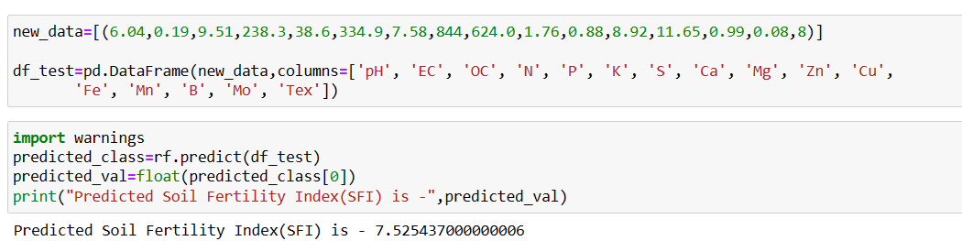

The image presents a compelling visualization of the predicted result generated by our innovative Soil Analyzer system when subjected to a new and previously unassessed set of soil data. To ensure the reliability and effectiveness of the Soil Analyzer project, extensive testing and validation with new data were conducted. This critical phase aimed to assess the accuracy of predictions and the overall usability of the system. The process involved feeding the machine learning model with fresh, previously unseen data and evaluating its performance.

For testing purposes, a sample dataset named "new_data" was created, which contained essential soil parameters. This dataset, which included attributes like pH, electrical conductivity (EC), organic carbon (OC), and various nutrient levels (N, P, K, S, Ca, Mg, Zn, Cu, Fe, Mn, B, Mo), aimed to simulate real-world conditions where users input their soil data for analysis.

The new data was then used to predict the Soil Fertility Index (SFI) using the trained Random Forest machine learning model. The predicted SFI value for the new data was found to be approximately 7.525, which serves as an actionable assessment of soil quality. The accuracy of the predictions was a crucial aspect of the testing process. The low error margin of approximately 0.03 and a high accuracy score of approximately 99.66% demonstrated the model's precision in assessing soil fertility levels. These results provided a strong indication of the system's capability to make reliable predictions based on user-provided data.

The usability of the system was also assessed during this testing phase. The web-based user interface, designed with a focus on user-friendliness, ensured that farmers and agricultural experts could input their soil data accurately and with ease. The validation protocols integrated into the interface further enhanced data quality, promoting accurate predictions.

The predicted SFI value of 7.525 signifies the assessed soil's fertility level on a scale of 1 to 10. In this context, 7.525 falls within the range of moderately fertile soil.

**Conclusion:**

The "Soil Analyzer" project has embarked on a journey to redefine the agricultural landscape through the transformative potential of machine learning. This endeavor, characterized by meticulous data collection, comprehensive analysis, and predictive modeling, lays the foundation for more efficient, cost-effective, and sustainable farming practices. As we conclude this venture, it becomes evident that the Soil Analyzer project is poised to leave an indelible mark on the world of agriculture.

The core objective of this project is to empower farmers with a valuable tool for optimizing their agricultural practices. By predicting the Soil Fertility Index (SFI), farmers can now make informed decisions about fertilizer application, saving time and reducing costs. This project's fundamental ethos is to enhance agricultural productivity, reduce waste, and promote sustainable farming practices. With a lower SFI indicating poorer soil fertility and a higher SFI reflecting greater fertility, farmers can precisely calculate the amount of fertilizer required to improve the soil, ultimately leading to increased crop yields and resource efficiency.

The heart of the Soil Analyzer project lies in its ability to derive meaningful insights from an extensive dataset. By combining pH, micronutrient levels, organic carbon, electrical conductivity, and soil texture, this project formulates the SFI, providing farmers with an actionable evaluation of soil quality. The project's machine learning model plays a pivotal role in translating this data into predictions, bridging the gap between raw information and actionable results. In a bid to make this project accessible to a wider audience, a user-friendly interface has been developed. This web-based platform enables farmers and agricultural experts to input their soil data with ease and receive real-time predictions. The interface represents a culmination of user-centric design and data-driven insights, allowing stakeholders to make informed decisions effortlessly.

The data collected and the machine learning model developed here can be extended and fine-tuned to accommodate evolving agricultural needs. Further research can explore the optimization of fertilizer usage, experimental soil improvement techniques, and the potential to incorporate more soil parameters and data sources into the analysis. The "Soil Analyzer" project represents a technological revolution in agriculture. By combining data-driven insights, predictive modeling, and a user-friendly interface, this project has bridged the gap between traditional farming practices and the era of smart agriculture. It empowers farmers to make informed, data-driven decisions that not only enhance productivity but also promote environmental sustainability.

**References:**

1. Kaggle Dataset prepared by G. B. Pant University of Agriculture and Technology.
2. Jamshed, Muhammad Ammar. “Analyze Soil Fertility Using Deep Learning Convolutional Neural Networks.” Shanlax International Journal of Arts, Science and Humanities, vol. 10, no. 3, 2023, pp. 1–5.
3. A Pandey, Shobhit & Kumar, Yogender & David, Arun. (2020). Research paper soil.
4. Prabhu, Shubham & Revandekar, Prem & Shirdhankar, Swami & Paygude, Sandip. (2020). Soil Analysis and Crop Prediction. International Journal of Scientific Research in Science and Technology. 117-123. 10.32628/IJSRST207433.
5. Bhavya Agarwal, Shubham Pokhriyal, Satvik Vats, Vikrant Sharma, Priyanshu Rawat, Madhvan Bajaj, "Crop Prediction Using Ensemble Learning", 2023 5th International Conference on Inventive Research in Computing Applications (ICIRCA), pp.90-95, 2023.
6. Jhansi Swetha, G. Kalyani, B. Kirananjali, "Advanced Soil Fertility Analysis and Crop Recommendation using Machine Learning", 2023 7th International Conference on Trends in Electronics and Informatics (ICOEI), pp.1035-1039, 2023.
7. Josephine Selle Jeyanathan, B. Medha, G. Tharun Venkata Sai, R. Bharath Kumar, Varsha Sahu, "Automated Crop Recommender System using Pattern Classifiers", 2023 International Conference on Intelligent Data Communication Technologies and Internet of Things (IDCIoT), pp.567-572, 2023.
8. Aditya Motwani, Param Patil, Vatsa Nagaria, Shobhit Verma and Sunil Ghane, "Soil Analysis and Crop Recommendation using Machine Learning", IEEE Conference, 2022.
9. Haedong Lee, Aekyung Moon, Gajeong- ro and Yuseong-gu, "Development of Yield Prediction System Based on Real-time Agricultural meteorological Information", ETRI 218 Gajeong-ro Yuseong-gu, pp. 305-700.
10. N, Raghu & K N, Manjunatha & B, Kiran & Chetia, Mr & Engineering, Electronics. (2020). COLLABORATIVE RESEARCH IN APPLIED SCIENCE AND ENGINEERING (CRASE) DESIGN AND DEVELOPMENT OF SMART SOIL ANALYSER. 1. 24.
11. Mot, Andrei & Ion, Violeta & Badulescu, Liliana & Roxana Maria, Madjar & Ciceoi, Roxana. (2022). SOIL QUALITY ASSESSMENT BASED ON THE C: N RATIO IN AN ALLUVIAL SOIL TREATED WITH MICROBIAL INOCULANTS.
12. Natarajan, Thangadurai & Sb, Vinay & Chikkalingaiah, Prasanna. (2019). Fertilizer Optimization by a Smart Soil Analyzer with a Soil Tester for Agriculture Applications. International Journal of Advanced Trends in Computer Science and Engineering. 8. 3628-3631. 10.30534/ijatcse/2019/146862019.
13. Pallevada, Hema & Velagapudi, Engineering & Siddhartha, Ramakrishna & Chandhra, Bharath & Gadde, Sai & Venkata, Teja & Munnangi, Kumar & Chinta, Mukesh. (2021). Real-time Soil Nutrient Detection and Analysis. 10.1109/ICACITE51222.2021.9404549.
14. Lin, J., Wang, M., Zhang, M., Zhang, Y., Chen, L. (2008). Electrochemical Sensors for Soil Nutrient Detection: Opportunity and Challenge. In: Li, D. (eds) Computer And Computing Technologies In Agriculture, Volume II. CCTA 2007. The International Federation for Information Processing, vol 259. Springer, Boston, MA.
15. Regalado, R G and Jennifer C. dela Cruz. “Soil pH and nutrient (Nitrogen, Phosphorus, and Potassium) analyzer using colorimetry.” 2016 IEEE Region 10 Conference (TENCON) (2016): 2387-2391.
16. Pyingkodi, M. et al. “IoT-based Soil Nutrients Analysis and Monitoring System for Smart Agriculture.” 2022 3rd International Conference on Electronics and Sustainable Communication Systems (ICESC) (2022): 489-494.